**LYNX SYNTHESIS REPORT**

Study Author: Cassandra Goodby

Date: 4/16/2019

1. Methodology
2. Summary
3. Recommendations
4. Group A Summary
5. Group B Summary

**METHODOLOGY**

This synthesis report is the result of a two-part study that observed participants using the prototype as well as the current apps available for use. The user test was done in multiple segments to test the different aspects and parts of the Lynx app. The first user test was conducted while snow shoeing and the second user test while skiing to duplicate the experience of the targeted audience. The first segment of the test was to have the users go about the experience as they normally would then interview them based upon that experience. The second segment of the test was to have a speaker playing music for the group then interview them on that portion. The next section was to imitate the experience of the app by creating a collaborative Spotify playlist and to sync the music by playing it from the beginning. The final step was to show them the prototype and talk them through the options and the likelihood that they would use each of the features. Other things tested for were pain points throughout each of the process.

**RESULTS SUMMARY**

Each stage of the test highlighted important aspects of the app and how it would perform once created. I have broken down some of the questions answered from each iteration below.

**Before Lynx Testing (Normal) Observations**

* Were the users listening to music?
  + **2 out of 3** users were already listening to music during the activity
* Did they feel disconnected from others?
  + **1 out of 3** felt disconnected due to not listening to music
  + **2 out of 3** enjoyed the music at a lower volume while still being able to talk with each other
  + **3 out of 3** agreed they would like music at some point during the 6 hour snowshoe
* Were their times when they couldn’t communicate to others due to the music?
  + ​There were a handful of times the users ​tried to communicate while listening to music
  + The two listening to music kept it at a low volume to be able to still talk with each other

**Takeaway:** Everyone agreed that they would enjoy music during the event. The two who were listening enjoyed it and were still able to contribute to the group but felt disconnected and thought the idea of being able to all listen to the same music was something they were interested in.

**Speaker Observations**

* Did they feel like they were having a more collaborative experience?
  + **3 out of 3** agreed they enjoyed being able to listen to music together
* Were they nervous to interrupt or annoy others?
  + **3 out of 3** agreed they did not want to interrupt others by their music who may be near
* Was it easier to communicate with everyone in the group?
  + Everyone was able to communicate while listening to music
* Was it annoying that one person was in control of the music?
  + **6 out of 6** wanted to queue up songs or add songs to the playlist to listen to

**Takeaway:** Everyone enjoyed listening to music together but wanted to be able to all add to the queue. They were also nervous about annoying surrounding people and “taking away from nature” by playing the loud music.

**Spotify Observations**

* Did everyone feel collaborative to the experience?
  + **6 out of 6**thought listening to the same music heightened the experience together
* No one person in control of the music?
  + **6 out of 6**enjoyed the ability to create a collaborative playlist and add their own music
* Unable to skip song or stay in sync?
  + **2 out of 6** skipped a song
  + **4 out of 6** said they really enjoyed being in sync with the songs
* Still have issue with communication?
  + **6 out of 6** agreed that they did not think it took away from being able to communicate as they were in close proximity with only one headphone in

**Takeaway:** Spotify is not a current solution to the problem as there were many issues during this test. In theory everyone agreed they liked the idea but it was too difficult and confusing to use spottily to achieve the same result as Lynx would offer.

**Prototype Observations**

* Sync vs solo mode?
  + **4 out of 6** said they were likely to switch between the two modes depending on the playlist and who they were with
  + **1 out of 6** said they would probably stay in sync mode unless someone skipped a ton of songs in a row
* Playlist creation feature?
  + **6 out of 6** said they liked being able to create a playlist together
  + **6 out of 6**said they liked being able to download the music to not waste battery
  + **2 out of 6**said they wished there was a voting system in place for songs
  + **2 out of 6**said they wished there was a way to reorder the songs
  + **4 out of 6** said they wanted to shuffle songs
  + **1 out of 3 (skiing)**said they would listen to the radio from the mountain if the music was good
* Walkie talkie and chat feature?
  + The walkie talkie feature was less popular for snow shoeing as we were in close enough proximity to talk **0 out of 3**
  + **3 out of 3** for skiing said if it worked well they would definitely use it to communicate with friends
    - Mostly to find each other or make plans of which run to do next
    - **2 out of 3** said it was not crucial to the app though and preferred the music capabilities

**Takeaway:**The groups really liked the overall concept and layout of the app. The prototype got very good feedback like being able to shuffle and reorder songs being a desire of some members of the group. The layout of the first page was confusing for some of how to get to the current playlist or to create a new group playlist. People liked the idea of the curated playlists from the skiing aspect but most said they would probably not use it.

**Other Pain Points Observations**

* Phone dying?
  + **5 out of 6** said they were concerned about phone battery especially in the cold
* Gloves in the way?
  + **3 out of 6** said they don’t love having to constantly take out their phones with gloves on as its difficult
* Safety of listening?
  + **2 out of 6** said they are concerned about listening to music while doing certain activities
  + **6 out of 6** said they only listen to one headphone on a lower volume to be able to hear their surroundings for safety
* Cell service?
  + **4 out of 6** said they were concerned about going in and out of service and the consistency of the app in sync mode
    - Once explained that they would go into solo mode when cell service or bluetooth was unavailable **6 out of 6** said that was a good solution

**Takeaway:** There are other issues outside of the current solution such a safety, cell service and battery life to keep in mind while designing the app. It was also interesting as these pain points were ones people were okay with their current solution (Spotify) but still desired a solution for. For Lynx I have kept these in mind with the dark UI for battery life, the bluetooth vs cell service vs solo mode, the apple watch UI and the ability to use your headphones to change songs.

**RECOMMENDATIONS**

1. *Chat feature:***3 participants** were observed saying they would use this feature (skiing) and 0 snowshoe participants were observed saying they would not use this feature
2. *Walkie Talkie feature:***6 participants** stated they would use this feature during certain activities and liked the save feature for the sound bites
   1. **6 participants** liked the walkie talkie feature over chat feature due to glove limitations
3. *Location tracking:***2 participants** were observed wanting this to be an experience the app could provide
4. *Cellular Service:***4 participants** were observed concerned about their cellular service for their app
5. *Sync vs Solo mode:***4 participants** were observed wanting to use this feature
   1. **1 participant** was observed unsure of the difference between these features until explained
6. *Playlist creation:***6 participants** were observed saying they would use this feature
   1. **1 participants** were observed wanting “Browse recommended” to be a feature they would not use
      1. **4 participant** were observed saying depending on how good the recommendation would be based upon songs already added in playlist they would use it
   2. **6 participants** were observed saying they would use “Browse song or artist” and “choose from playlist"
   3. **6 participants** stated that they have issues with Spotify search algorithm and being able to find songs
7. *Downloading music:***6 participants** were observed saying this was crucial to the app
8. *Connection with other apps:***6 participants** were observed saying they liked it being connected to Spotify as that is their current solution to music
   1. **0 participants** were observed saying they desired connection to any other music streaming service
9. *Curated playlists:***1 participants** were observed saying they would use this
   1. **3 participants** were observed wanting this to be an option but are unsure if they would use it
10. *Save playlists:***2 participants** were observed saying they would save their playlist to Spotify
    1. **6 participants** were observed saying this was not a crucial aspect of the app
11. *Mute feature:***6 participants** were observed saying they would not use this feature as hearing from the group is important
12. *Adding friends:***4 participants** were observed wanting this to be a better experience and were confused about how to get to the screen
    1. **4 participants**were observedsaying the initial creation of a new playlist need to be a better experience and at the forefront of the app

**GROUP A-Snowshoe**

**Participants**

Gabby

Phelan

Bryce

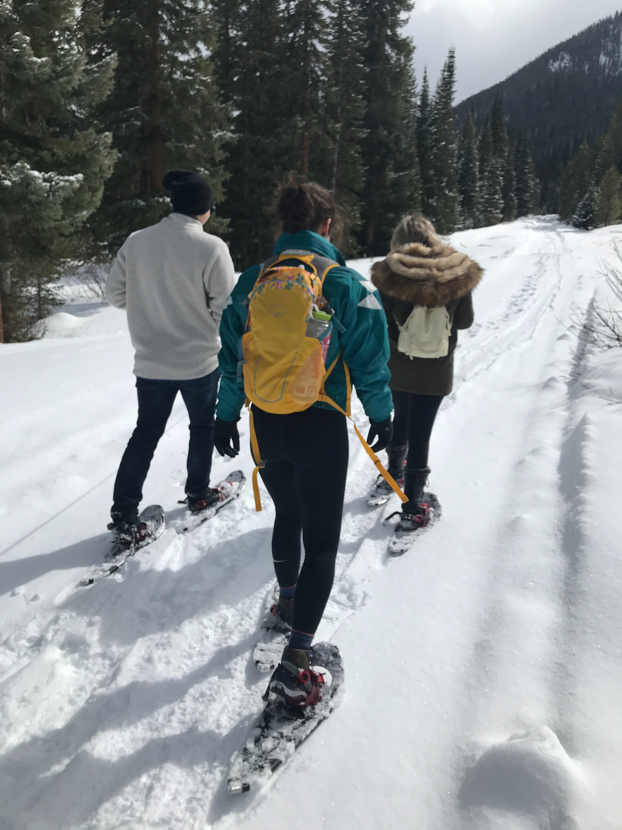

**Participant Quotes**

“The music adds to the experience while still feeling like I’m with friends”

“I don’t think I would use the chat or walkie talkie feature much during this activity since I wouldn’t move very far away from the group”

“I would definitely use this while at the gym, skiing or hiking"

“I am not great at choosing music and would prefer my friend DJ for me”

“It's like a silent disco"

“I hate using speakers when hiking or outdoors as I don’t want to be that douchebag who forces everyone to listen to my type of music if they are trying to enjoy the outdoors"

**GROUP B-Skiing**

**Participants**

Charlie

Sammi

Jackson

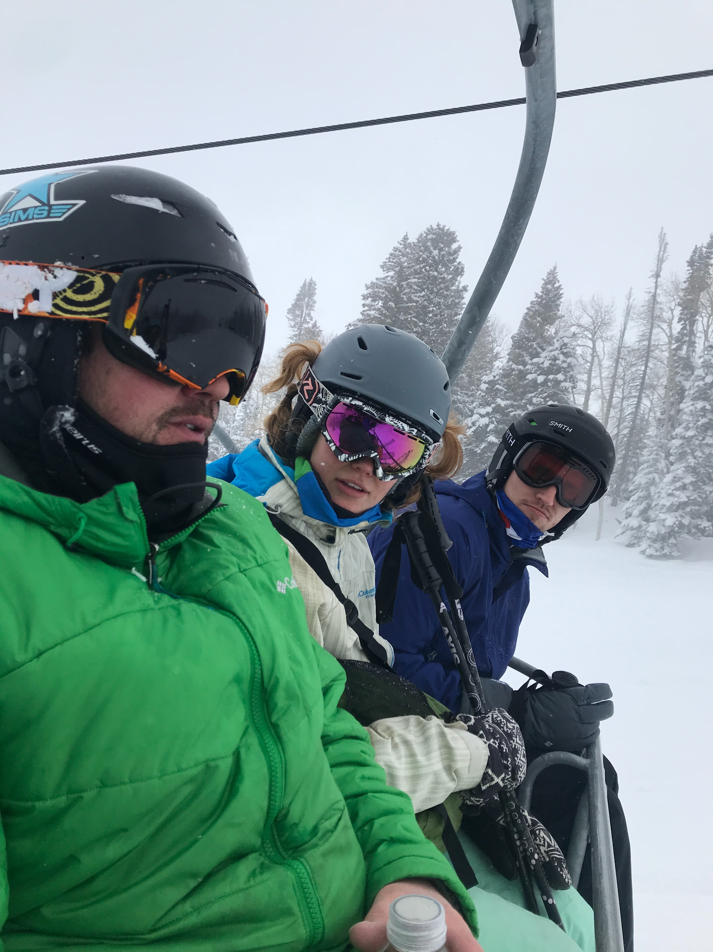

**Participant Quotes**

“I like the walkie talkie feature but wish I didn’t have to take my phone out of my jacket in order to use it”

“My gloves get in the way of using some of the features so only can really use it before skiing or on the chairlift”

“My phone goes out of service so I’m concerned how well it would work when that happens"

“I only listen to music with one headphone to stay aware of my surroundings while skiing”

“A tracking feature of friends would be awesome to see where they are on the mountain when I lose them or if we separate”

“I have tried to sync music with groups in the past while skiing and haven’t been able to”

“I have never thought of creating a collaborative playlist with my friends before and like the idea of being able to do so for certain activities”

“I think this app is perfect for skiing"